**MAHARASHTRA STATE BOARD OF TECHNICAL**

**EDUCATION, MUMBAI**

**GOVERNMENT POLYTECHNIC,**

**JALGAON**

**DEPARTMENT OF ELECTRONICS & TELECOMMUNICATION ENGINEERING**



**A CAPSTONE PROJECT PLANNING**

On

“Electroplating bath parameters monitoring system”

**Submitted by**

Saraf Prathamesh G.

Bhangale Mohit R.

Patil Mandar B.

Khadse Mohish N.

**Under the guidance of**

**Prof. K. P. Akole**

**2020-21**

**MAHARASHTRA STATE BOARD OF TECHNICAL**

**EDUCATION, MUMBAI**

**GOVERNMENT POLYTECHNIC,**

**JALGAON**

**DEPARTMENT OF ELECTRONICS & TELECOMMUNICATION ENGINEERING**

**ACADEMIC YEAR 2020-21**

**Certificate**

This is to certify that Mr Prathamesh Saraf , Mohit Bhangale , Mandar Patil , Mohish Khadse from Government Polytechnic , Jalgoan college having Enrollment No 1800180265 , 1800180288 , 1800180290 , 1800180291 has completed capstone project planning report on

**“Electroplating Bath Parameters Monitoring System”**

This report is submitted as partial fulfilment of requirement of diploma course in Electronic And Tele-communication engineering prescribed by M.S.B.T.E Mumbai

**Prof K.P.Akole Principal Prof K.P.Akole**

(Project Guide) (Govt. Poly, Jalgoan ) (H.O.D E&TC Dept.)

**Acknowledgement**

Finally Iwould like to express our appreciation to ou capstone project guide ,our department HOD Mr K.P Akole sir. His constant guidance advice palyed a vital role in making the execution of the report. He always gave his required suggestions that were crucial in making report better. Guidance of the our sir has consistently keep us motivated for project planning. He has taken every possible step to improve us not only in a project but also in social activities which were going to improve our project and working attitude towards our project. We again thank you sir for your support.

**Project Participants**

* Prathemesh Saraf
* Mohit Bhangale
* Mandar Patil
* Mohish Khadse

**Abstract**

The project which we are going to make covers two major steps

1. It is based on the live industrial problem which is shared by company itself (Spectrum Electrical Ltd)
2. And company itself is ready to give the technical sponsorship required for the project

The problem given by the industry is that in the electroplating plant of the industry there is a need of a system which require to monitor a parameters such as liquid PH value,Methane and carbon monoxide gases content of electroplating bath container not only monitoring but the want the data to be fetched in their plant office with wireless technology

So the solution for these problem can be to construct the system which will measure such parameters from bath and transmit into the office. These parameters which are water, PH level, Carbon Monoxide gas, methane gas temperature of electrolyte solution can be sensed by the sensors. Sensors output will be feed to the controller where the sensed parameter will be converted in the real time readable format and further send to the office through the transmitter module. At the reception section of the system this data will be displayed on the lcd screen and system such as, if the measured parameter value rises above the required level a small alaram will activate which will inform that parameters of bath had exceeds its tolerating value

So to complete the project successfully we have to do the literature survey of the components required for the project for eg literature survey of the sensors for given task, their compatibility with the controller survey of display devices the compatibility with controller , effective rf module to meet the wireless range for the display of data, to choose the appropriate programming environment,study of all the programming knowledge to programm the components and last but not least simulation of the complete project and last its implementation in the industry.

**Index**

|  |  |  |
| --- | --- | --- |
| **Sr.no** | **Topic** | **Pg no** |
| 1 | Chapter 1: Introduction of the Capstone project | 6 |
| 2 | Chapter 2 : Literature survey Done for selecting a problem identification for Capstone project | 7 |
| 3 | Chap 3 -: Project management Cycle | 8 |
| 4 | Chapter no 4 -: Hardware required for the projects | 12 |
| 5 | Chapter No 5 -: Software required for the project | 28 |

**Chapter 1: Introduction of the Capstone project**

Processlike deposition ,doping, electroplating creates the toxic gases in the processing plant. This gases are used as a catalyst in the process. This gases sre surely enabler in the processing but are highly toxic and can cause concussion when inhaled. Additional acids like HCL are also used in these companies for similar purpose fumes can cause irritation & affect the respiration of the inhaler Whether these gases are used for manufacturing or byproducts of any process in a facility it becomes very important to monitor and control them.

Therefore gas detection system can be easily integrated into existing system & equipment of a company, allowing easy detection of gas leakages that can result in several catastrophe. Quick action can hence be taken to prevent the spread of gas over a wide region. These systems are an essential commodities in such industries. Since the allow them to detect the leakage of noxious and explosive gases maintain proper oxygen level for workers and company with emission regulation norms.

Gas sensors (also known as gas detectors) are electronic devices that detect and identify different types of gasses. They are commonly used to detect toxic or explosive gasses and measure gas concentration. Gas sensors are employed in factories and manufacturing facilities to identify gas leaks, and to detect smoke and carbon monoxide in homes.

Gas sensors vary widely in size (portable and fixed), range, and sensing ability. They are often part of a larger [embedded system](https://www.fierceelectronics.com/embedded/what-embedded-computer), such as security systems, and they are normally connected to an audible alarm or interface. Because gas sensors are constantly interacting with air and other gasses, they have to be calibrated more often than many other types of sensors.

MQ2 is one of the commonly used gas sensors in MQ sensor series. It is a Metal Oxide Semiconductor (MOS) type Gas Sensor also known as Chemiresistors as the detection is based upon change of resistance of the sensing material when the Gas comes in contact with the material. Using a simple voltage divider network, concentrations of gas can be detected.

An RF module (short for radio-frequency module) is a (usually) small electronic device used to transmit and/or receive radio signals between two devices. In an [embedded system](https://en.wikipedia.org/wiki/Embedded_system) it is often desirable to communicate with another device [wirelessly](https://en.wikipedia.org/wiki/Wireless). This wireless communication may be accomplished through [optical communication](https://en.wikipedia.org/wiki/Free-space_optical_communication) or through [radio-frequency](https://en.wikipedia.org/wiki/Radio-frequency) (RF) communication. For many applications, the medium of choice is RF since it does not require line of sight. RF communications incorporate a [transmitter](https://en.wikipedia.org/wiki/Transmitter) and a [receiver](https://en.wikipedia.org/wiki/Receiver_(radio)). They are of various types and ranges. Some can transmit up to 500 feet. RF modules are typically [fabricated](https://en.wikipedia.org/wiki/Semiconductor_device_fabrication) using [RF CMOS](https://en.wikipedia.org/wiki/RF_CMOS) technology.

RF modules are widely used in electronic design owing to the difficulty of designing radio circuitry. Good electronic radio design is notoriously complex because of the sensitivity of radio circuits and the accuracy of components and layouts required to achieve operation on a specific frequency. In addition, reliable RF communication circuit requires careful monitoring of the manufacturing process to ensure that the RF performance is not adversely affected. Finally, radio circuits are usually subject to limits on radiated emissions, and require [Conformance testing](https://en.wikipedia.org/wiki/Conformance_testing) and certification by a [standardization](https://en.wikipedia.org/wiki/Standardization) organization such as [ETSI](https://en.wikipedia.org/wiki/ETSI) or the U.S. [Federal Communications Commission](https://en.wikipedia.org/wiki/Federal_Communications_Commission) (FCC). For these reasons, design engineers will often design a circuit for an application which requires radio communication and then "drop in" a pre-made radio module rather than attempt a [discrete](https://en.wikipedia.org/wiki/Discrete_device) design, saving time and money on development.

Several carrier frequencies are commonly used in commercially available RF modules, including those in the [industrial, scientific and medical (ISM) radio bands](https://en.wikipedia.org/wiki/ISM_band) such as 433.92 MHz, 915 MHz, and 2400 MHz. These frequencies are used because of national and international regulations governing the used of radio for communication. [Short Range Devices](https://en.wikipedia.org/wiki/Short_Range_Devices) may also use frequencies available for unlicensed such as 315 MHz and 868 MHz. RF modules may comply with a defined protocol for RF communications such as [Zigbee](https://en.wikipedia.org/wiki/Zigbee), [Bluetooth Low Energy](https://en.wikipedia.org/wiki/Bluetooth_Low_Energy), or [Wi-Fi](https://en.wikipedia.org/wiki/Wi-Fi), or they may implement a [proprietary protocol](https://en.wikipedia.org/wiki/Proprietary_protocol).

**Chapter 2 : Literature survey Done for selecting a problem identification for Capstone project**

First we have decided top make a project to make full body sanitizer machine for the department. We were very close to find a effective way to make our product cost effective,and were studying on how to introduce our product to market. But while working on it we find out the type of product which we are going to make was restricted to use on because of some harmful effects of liquid sanitizer on the human beings. So we quit our working on that project

Then we try to reach the various industries to get the problem statement so we can try to find out the solution the it as our project. Then we get a belove given problem which was given by the Spectrum Electrical Industry Pvt.Ltd.

The problem given by the industry is that in the electroplating plant of the industry there is a need of a system which require to monitor a parameters such as liquid PH value,Methane and carbon monoxide gases content of electroplating bath container not only monitoring but the want the data to be fetched in their plant office wirelessly

Methods for solution the identified problem can be as follows

**Flexible system** -: System shiuld be so flexible which will easily adapt the electroplating plant environment.and can be easily transferred to another container. Also if require it can be modified as per further requirement(which includes switching action of the inlet and outlet valve of the electroplating bath,diluting the electrolyte solution etc )

**Wireless system**-: This monitoring system should be wireless because at the actual project implementing site there is no such place to carriy the wires towards office

**Alarm provision** -: System should have the alarm provision which will inform that bath parameters has cross the threshold value.

**Compact Size** -: System should be compact so it can be attached at at the site

**Chapter 3 -:**

**Project management Cycle**

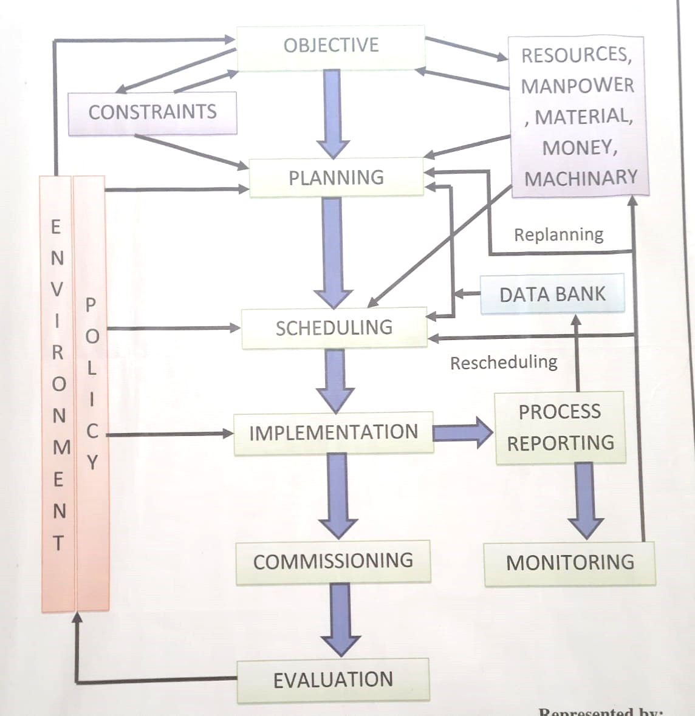

**Fig 3.1 project management cycle**

**Objectives -:**

* 1)To develop a monitoring system for the electroplating bath.
* To transfer the data sensed by the sensors to electroplating plant office through wireless technology

**Environment Policy -:**

* Time availability for the project
* Different factors affecting industrial timing (such as change in production cycle of the industry)
* Various factors affecting the academic calender of MSBTE
* Atmospheric and natural issues

**Planning –:**

* Project planning will be according to given action plan

|  |  |  |  |  |  |  |
| --- | --- | --- | --- | --- | --- | --- |
| **Sr No** | | **Detail Activity** | **Planned**  **Start date** | | | **Planned**  **End Date** |
| **1** | | **Selecting capston project** | **24-08-2020** | | | **21-09-2020** |
| **2** | | **Discussion of project with mentor** | **22-9-2020** | | | **12-10-2020** |
| **3** | | **Finalization of topic from mentor** | **13-10-2020** | | | **30-10-2020** |
| **When we discuss about our capstone project with industry then industry has given own problem ststement then we cancel then we cancel out topic and start with industry problem** | | | | | | |
| **1** | **Seeking for industry to get technical guidance and problem ststement** | | | **27-12-2020** | **27-12-2020** | |
| **2** | **Selecting topic for project** | | | **27-12-2020** | **01-01-2021** | |
| **3** | **Discussion of project with mentor** | | | **01-01-2021** | **04-01-2021** | |
| **4** | **Submitting the proposal of the project** | | | **06-01-2021** | **06-01-2021** | |
| **5** | **Study of the resources required for the project** | | | **7-1-2021** | **12-01-2021** | |
| **6** | **Study and selection of the hardware and software required for the project** | | | **13-01-2021** | **20-01-2021** | |
| **7** | **Preparation of the report on capstone project planning** | | | **21-01-2021** | **26-01-2021** | |
| **8** | **Submission of the report on capstone project planning** | | | **27-01-2021** | **28-01-2021** | |
| **9** | **Reporting the industrial executive about project planning done and ask his review on planning** | | | **28-01-2021** | **15-02-2021** | |
| **10** | **Simulation of the project** | | | **24-03-2021** | **29-03-2021** | |
| **11** | **Reporting the industrial executive for project programming and simulation done** | | | **27-03-2021** | **05-04-2021** | |
| **12** | **Inspection of simulation project under industry executive surveillance** | | | **02-04-2021** | **05-04-2021** | |
| **13** | **Actual implementing the project** | | | **05-04-2021** | **30-04-2021** | |
| **14** | **Final submission of the project** | | | **01-05-2021** | **20-05-2021** | |

**Scheduling-:**

Project scheduling include two major term

**1st term** i.e5th sem from the month of August 2020 to January 2021 includes Capstone project planning. The activities in capstone project planning consist of

* Formation of group for project
* Seeking to industries to get live problem statement
* Selection of the capstone project
* Discussing with the industry mentor and with project guide in collage for selecting the resourses , hardware software and components for project
* Preparing and submitting the planning report

**2nd Term** i.e 6th sem form month of March 2021 to May2021 includes capstone project execution . The activities in capstone project execution consist of

* Simulation of the project
* Purchasing the components required for the project
* Implementation of the project in industry
* Submitting the report on implementation of the project

**Implementation-:**

|  |  |  |
| --- | --- | --- |
| **Sr no** | **Activities** | **Implemented / not implemented** |
| 1 | Formation of the project group | **Implemented** |
| 2 | Seeking to industries to get live problem statement | **Implemented** |
| 3 | Selection of the project | **Implemented** |
| 4 | Propose planning for the project | **Implemented** |
| 5 | Selection of the resources required for the project | **Implemented** |
| 6 | Submission of the report on the capstone project planning | **not implemented** |
| 7 | simulation of the project | **not implemented** |
| 8 | Purchasing the components required for the project | **not implemented** |
| 9 | Implementation of the project in industry | **not implemented** |
| 10 | Submitting the report on implementation of the project | **not implemented** |

**Commissioning-:**

Commissioning of the project will be in the month of May 2021

Before the commissioning assembly of the project & programming will be done

**Process reporting -:**

After the formation of the group for project and securing the problem statement from the Spectrum Electrical Industries Pvt. Ltd. Listed process has been carried out

* Study of the electroplating plant
* ,Discussion with the expert for project planning,
* discussion with the project mentor for selection of various components

In the coming duration remaining process will be carried out such as.

* simulation of the project
* Implementation of the project in industry

Thus the project will be get completed before target date.

**Constraints-:**

As the project is industrial sponsor so the major constraint is availability of the components mainly sensors

Costing may be a constraint if the cost of project gets very high beyond expection.

**Resources**

Arduino.cc

Wikipedia

Lastminute engineering.com

Alldatasheet.com

Tinkercad.com

Spectrum Electrical Pvt.Ltd

**Chapter no 4 -: Hardware required for the projects**

**Block diagram of the system**

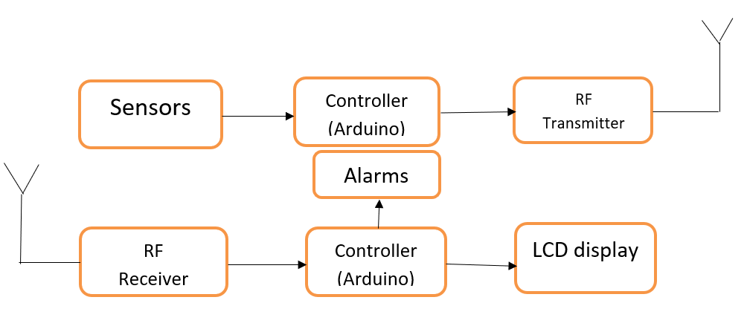

**Fig 4.1 block diagram of the system**

**Arduino**

Arduino is an open-source electronics platform based on easy-to-use hardware and software. [Arduino boards](https://www.arduino.cc/en/Main/Products) are able to read inputs - light on a sensor, a finger on a button, or a Twitter message - and turn it into an output - activating a motor, turning on an LED, publishing something online. You can tell your board what to do by sending a set of instructions to the microcontroller on the board. The Arduino board is not a Microcontroller, it is an open source electronics platform. The Arduino board is a PCB which has Microcontrollers, LED’s, and many other connections. Generally, it is used to do input & output operations like to control a motor, read from the [sensor](https://www.watelectronics.com/different-types-of-sensors-with-applications/) and in small computations.

There are many other microcontrollers and microcontroller platforms available for physical computing. Parallax Basic Stamp, Netmedia's BX-24, Phidgets, MIT's Handyboard, and many others offer similar functionality. All of these tools take the messy details of microcontroller programming and wrap it up in an easy-to-use package. Arduino also simplifies the process of working with microcontrollers, but it offers some advantage for teachers, students, and interested amateurs over other systems:

* **Inexpensive** - Arduino boards are relatively inexpensive compared to other microcontroller platforms. The least expensive version of the Arduino module can be assembled by hand, and even the pre-assembled Arduino modules cost less than $50
* **Cross-platform** - The Arduino Software (IDE) runs on Windows, Macintosh OSX, and Linux operating systems. Most microcontroller systems are limited to Windows.
* **Simple, clear programming environment** - The Arduino Software (IDE) is easy-to-use for beginners, yet flexible enough for advanced users to take advantage of as well. For teachers, it's conveniently based on the Processing programming environment, so students learning to program in that environment will be familiar with how the Arduino IDE works.
* **Open source and extensible software** - The Arduino software is published as open source tools, available for extension by experienced programmers. The language can be expanded through C++ libraries, and people wanting to understand the technical details can make the leap from Arduino to the AVR C programming language on which it's based. Similarly, you can add AVR-C code directly into your Arduino programs if you want to.
* **Open source and extensible hardware** - The plans of the Arduino boards are published under a Creative Commons license, so experienced circuit designers can make their own version of the module, extending it and improving it. Even relatively inexperienced users can build the [breadboard version of the module](https://www.arduino.cc/en/Main/Standalone) in order to understand how it works and save money.

**Types of Arduino Boards**

There are different Arduino boards which are following

* [Arduino Uno](https://www.digikey.in/product-detail/en/dfrobot/DFR0216/1738-1228-ND/6579366)
* [Arduino Nano](https://www.digikey.in/product-detail/en/arduino/A000005/1050-1001-ND/2638989)
* [Arduino Due](https://www.digikey.in/product-detail/en/arduino/A000062/1050-1049-ND/3712582)
* [Arduino Mega](https://www.digikey.in/product-detail/en/arduino/A000067/1050-1018-ND/2639006)
* [Arduino MKR Zero](https://www.digikey.in/product-detail/en/arduino/ABX00012/1050-1137-ND/6829065)
* Arduino YÚN
* Arduino Ethernet REV 3

**Different types of arduino feature**

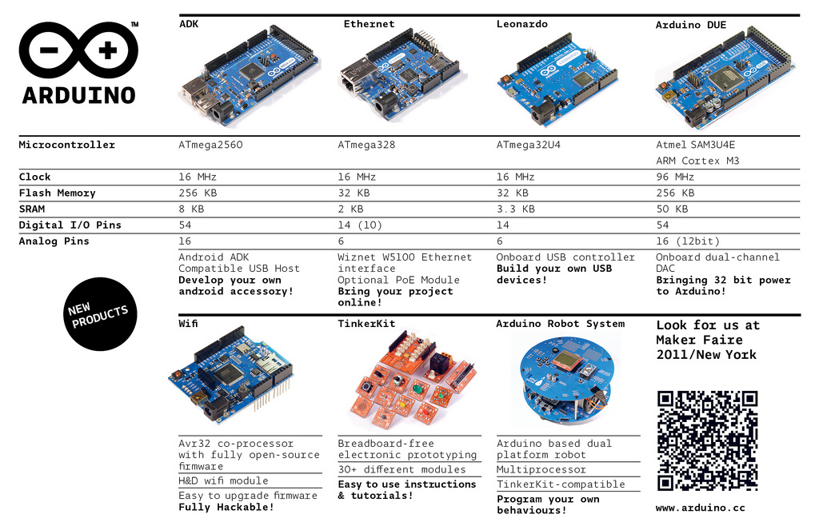

If you are new to the Arduino, then there are two devices that immediately come to mind: the Arduino Uno and the Arduino Nano. The Arduino Uno is one of the most common Arduino boards available, and it has some user-friendly features, including large 2.54mm pitched sockets for connecting to external devices, an onboard LED, inbuilt power handling (such as an external DC power jack), and a large USB B connector for connecting to a PC. The Arduino Nano has most of the same features (with the exception of a smaller USB port and no DC power jack), but it is better suited for projects using breadboards. This makes it optimal for those who are already electronic-savvy and who already have breadboard circuits ready. The Nano is also very small (18mm by 45mm), and it’s ideal for situations where portability is important.

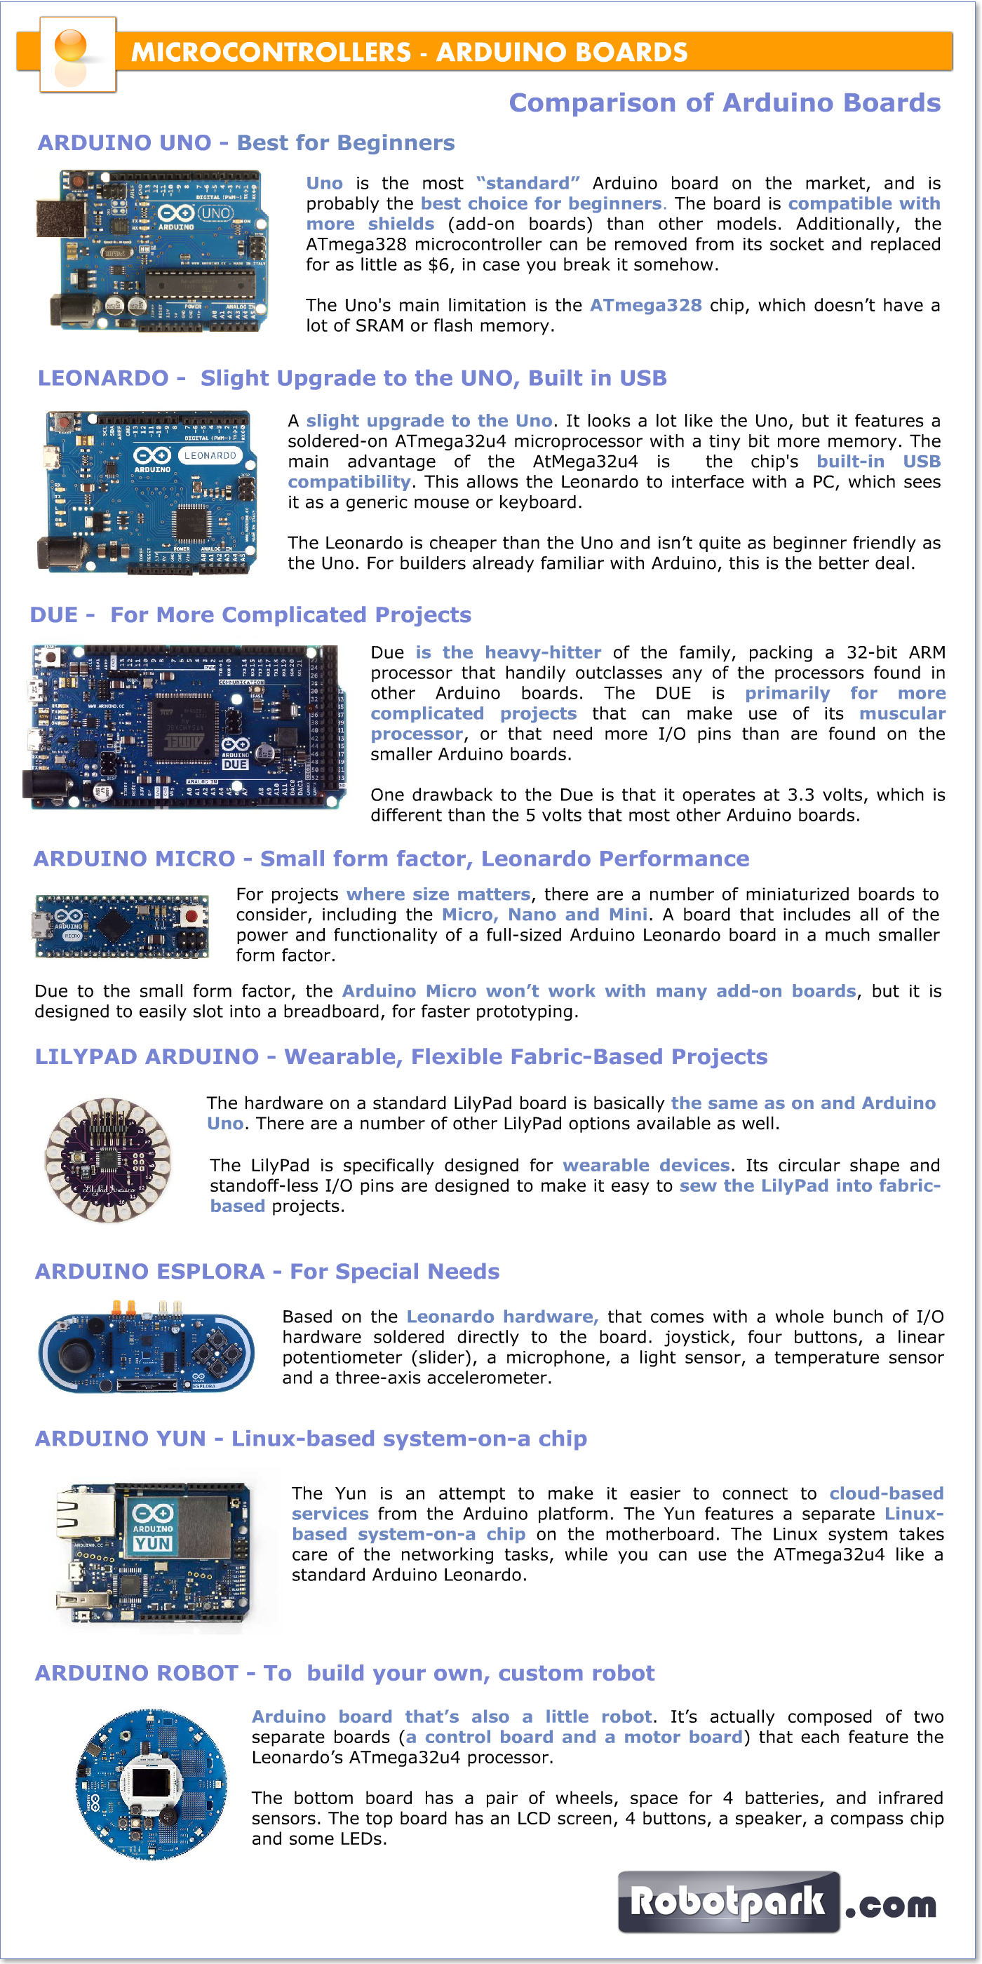

# **Arduino Uno(** **R3 ATmega328P)**

The Arduino Uno is an [open-source](https://en.wikipedia.org/wiki/Open-source) [microcontroller board](https://en.wikipedia.org/wiki/Microcontroller_board) based on the  [Microchip](https://en.wikipedia.org/wiki/Microchip_Technology) [ATmega328P](https://en.wikipedia.org/wiki/ATmega328P) microcontroller and developed by [Arduino.cc](https://en.wikipedia.org/wiki/Arduino). The board is equipped with sets of digital and analog [input/output](https://en.wikipedia.org/wiki/Input/output) (I/O) pins that may be interfaced to various [expansion boards](https://en.wikipedia.org/wiki/Expansion_board) (shields) and other circuits. The board has 14 digital I/O pins (six capable of [PWM](https://en.wikipedia.org/wiki/Pulse-width_modulation) output), 6 analog I/O pins, and is programmable with the [Arduino IDE](https://en.wikipedia.org/wiki/Arduino#Software) (Integrated Development Environment), via a type B [USB cable](https://en.wikipedia.org/wiki/USB_cable). It can be powered by the USB cable or by an external [9-volt battery](https://en.wikipedia.org/wiki/9-volt_battery), though it accepts voltages between 7 and 20 volts. It is similar to the [Arduino Nano](https://en.wikipedia.org/wiki/Arduino_Nano) and Leonardo. The hardware reference design is distributed under a [Creative Commons](https://en.wikipedia.org/wiki/Creative_Commons) Attribution Share-Alike 2.5 license and is available on the Arduino website. Layout and production files for some versions of the hardware are also available.

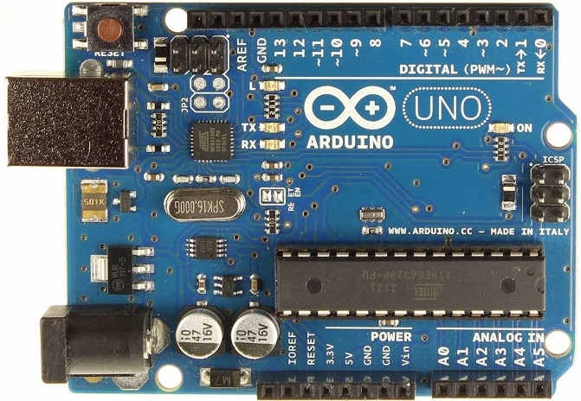

**Fig 4.2**

**Specification of Arduino uno -:**

* Operating Voltage: 5 Volts
* Input Voltage: 7 to 20 Volts
* Digital I/O Pins: 14 (of which 6 can provide PWM output)
* UART: 1
* I2C: 1
* SPPI: 1
* Analog Input Pins: 6
* DC Current per I/O Pin: 20 mA
* DC Current for 3.3V Pin: 50 mA
* [Flash Memory](https://en.wikipedia.org/wiki/Flash_Memory): 32 KB of which 0.5 KB used by [bootloader](https://en.wikipedia.org/wiki/Booting#BOOT-LOADER)
* [SRAM](https://en.wikipedia.org/wiki/Static_random-access_memory): 2 KB
* [EEPROM](https://en.wikipedia.org/wiki/EEPROM): 1 KB
* Clock Speed: 16 MHz
* Length: 68.6 mm
* Width: 53.4 mm
* Weight: 25 g

**General pin functions**

* **LED**: There is a built-in LED driven by digital pin 13. When the pin is high value, the LED is on, when the pin is low, it is off.
* **VIN**: The input voltage to the Arduino/Genuino board when it is using an external power source (as opposed to 5 volts from the USB connection or other regulated power source). You can supply voltage through this pin, or, if supplying voltage via the power jack, access it through this pin.
* **5V**: This pin outputs a regulated 5V from the regulator on the board. The board can be supplied with power either from the DC power jack (7 - 20V), the USB connector (5V), or the VIN pin of the board (7-20V). Supplying voltage via the 5V or 3.3V pins bypasses the regulator, and can damage the board.
* **3V3**: A 3.3 volt supply generated by the on-board regulator. Maximum current draw is 50 mA.
* **GND**: Ground pins.
* **IOREF**: This pin on the Arduino/Genuino board provides the voltage reference with which the microcontroller operates. A properly configured shield can read the IOREF pin voltage and select the appropriate power source, or enable voltage translators on the outputs to work with the 5V or 3.3V.
* **Reset**: Typically used to add a reset button to shields that block the one on the board

**Special pin functions**

Each of the 14 digital pins and 6 analog pins on the Uno can be used as an input or output, under software control (using pinMode(), digitalWrite(), and digitalRead() functions). They operate at 5 volts. Each pin can provide or receive 20 mA as the recommended operating condition and has an internal pull-up resistor (disconnected by default) of 20-50K ohm. A maximum of 40mA must not be exceeded on any I/O pin to avoid permanent damage to the microcontroller. The Uno has 6 analog inputs, labeled A0 through A5; each provides 10 bits of resolution (i.e. 1024 different values). By default, they measure from ground to 5 volts, though it is possible to change the upper end of the range using the AREF pin and the analogReference() function.

In addition, some pins have specialized functions:

* **Serial** / [UART](https://en.wikipedia.org/wiki/UART): pins 0 (RX) and 1 (TX). Used to receive (RX) and transmit (TX) TTL serial data. These pins are connected to the corresponding pins of the ATmega8U2 USB-to-TTL serial chip.
* **External interrupts**: pins 2 and 3. These pins can be configured to trigger an interrupt on a low value, a rising or falling edge, or a change in value.
* [**PWM**](https://en.wikipedia.org/wiki/Pulse-width_modulation) (pulse-width modulation): pins 3, 5, 6, 9, 10, and 11. Can provide 8-bit PWM output with the analogWrite() function.
* [**SPI**](https://en.wikipedia.org/wiki/Serial_Peripheral_Interface) (Serial Peripheral Interface): pins 10 (SS), 11 (MOSI), 12 (MISO), and 13 (SCK). These pins support SPI communication using the SPI library.
* **TWI** (two-wire interface) / [I²C](https://en.wikipedia.org/wiki/I%C2%B2C): pin SDA (A4) and pin SCL (A5). Support TWI communication using the Wire library.
* **AREF** (analog reference): Reference voltage for the analog inputs.

**Sensor -:**

A sensor is a device that measures physical input from its environment and converts it into data that can be interpreted by either a human or a machine. Most sensors are electronic (the data is converted into electronic data), but some are more simple, such as a glass thermometer, which presents visual data.

**Types of sensor-:**

* Vision and Imaging Sensors.
* Temperature Sensors.
* Radiation Sensors.
* Proximity Sensors.
* Pressure Sensors.
* Position Sensors.
* Photoelectric Sensors.
* Particle Sensors.

# **Temperature sensor**

A temperature sensor is an electronic device that measures the temperature of its environment and converts the input data into electronic data to record, monitor, or signal temperature changes. There are many different types of temperature sensors. Some temperature sensors require [direct contact](https://www.electronics-tutorials.ws/io/io_3.html) with the physical object that is being monitored (contact temperature sensors), while others indirectly measure the temperature of an object (non-contact temperature sensors).

# **DS18B20 Waterproof Digital Temperature Thermal Probe Sensor**

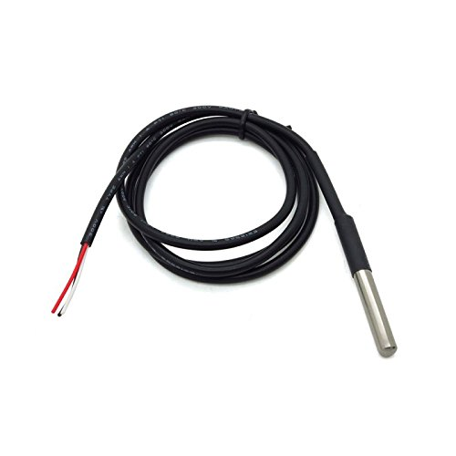

**Fig 4.3**

Handy for when you need to measure something far away, or in wet conditions. While the sensor is good up to 125Â°C the cable is jacketed in PVC so we suggest keeping it under 100Â°C. Because they are digital, you don't get any signal degradation even over long distances! These 1-wire digital temperature sensors are fairly precise (Â±0.5Â°C over much of the range) and can give up to 12 bits of precision from the onboard digital-to-analog converter. They work great with any microcontroller using a single digital pin, and you can even connect multiple ones to the same pin, each one has a unique 64-bit ID burned in at the factory to differentiate them. Usable with 3.0-5.0V systems.

**Features:**

* Each pin uses a heat-shrinkable tube to prevent short circuits, internal sealing glue.
* Stainless steel tube encapsulation waterproof moistureproof prevents rust.
* Stainless steel tube 6mm diameter by 30mm long.
* Contains a DS18B20 temperature sensor.
* Uses 1-Wire interface- requires only one digital pin for communication.
* Unique 64 bit ID burned into the chip.
* Multiple sensors can share one pin.
* Temperature-limit alarm system.
* Without the external components, the unique single bus.

# **Carbon Monoxide Gas Sensor(MQ-7)**

Sensitive material of MQ-7 gas sensor is SnO2, which with lower conductivity in clean air. It make detection by method of cycle high and low temperature, and detect CO when low temperature (heated by 1.5V). The sensor’s conductivity is more higher along with the gas concentration rising. When high temperature (heated by 5.0V), it cleans the other gases adsorbed under low temperature. Please use simple electrocircuit, Convert change of conductivity to correspond output signal of gas concentration. MQ-7 gas sensor has high sensitity to Carbon Monoxide. The sensor could be used to detect different gases contains CO, it is with low cost and suitable for different application.

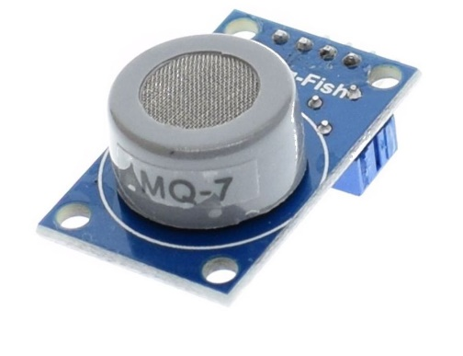

**Fig 4.4**

**Character Configuration**

* Good sensitivity to Combustible gas in wide range
* High sensitivity to Natural gas
* Long life and low cost
* Simple drive circuit

**Technical Data**

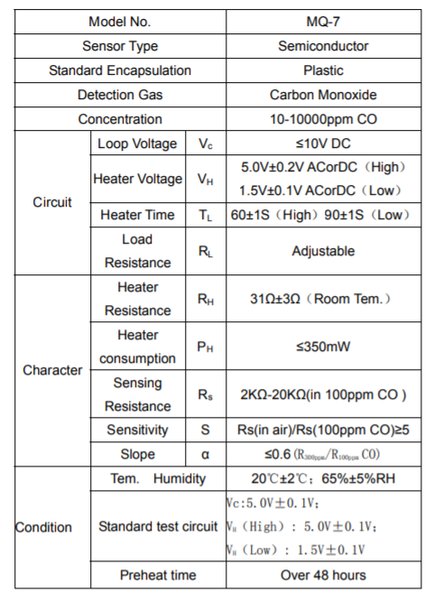

**Basic test loop**

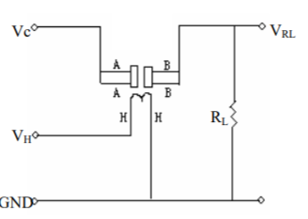

**Fig 4.5**

The above is basic test circuit of the sensor. The sensor need to be put 2 voltage, heater voltage（VH） and test voltage（VC）. VH used to supply certified working temperature to the sensor, while VC used to detect voltage (VRL) on load resistance （RL）whom is in series with sensor. The sensor has light polarity, Vc need DC power. VC and VH could use same power circuit with precondition to assure performance of sensor. In order to make the sensor with better performance, suitable RL value is needed: Power of Sensitivity body(Ps): Ps=Vc2 ×Rs/(Rs+RL)2

**specifications**

1. Operating voltage: DC 5 V.
2. The analog output voltage, the higher the concentration the higher the voltage.
3. The carbon monoxide detection with better sensitivity.
4. With a long service life and reliable stability.
5. Rapid response and recovery characteristics.
6. Range: 10 to 1000 ppm.

#### **Features :**

1. The analog output voltage, the higher the concentration the higher the voltage.
2. The carbon monoxide detection with better sensitivity.
3. There are four screw holes for easy positioning.
4. With a long service life and reliable stability.
5. Rapid response and recovery characteristics.

**Application**

* Domestic gas leakage detector
* Industrial CO detector
* Portable gas detector

**PH meter SKU SEN0161**

Need to measure water quality and other parameters but haven't got any low cost pH meter? Find it difficult to use with [Arduino](https://www.dfrobot.com/category-35.html)? Here comes an analog pH meter, specially designed for [**Arduino controllers**](https://www.dfrobot.com/category-104.html)and has built-in simple, convenient and practical connection and features. It has an LED which works as the Power Indicator, a BNC connector and PH2.0 sensor interface. To use it, just connect the pH sensor with BNC connector, and plug the PH2.0 interface into the analog input port of any [Arduino controller](https://www.dfrobot.com/category-104.html). If pre-programmed, you will get the pH value easily. Comes in compact plastic box with foams for better mobile storage. **Attention:In order to ensure the accuracy of the pH probe, you need to use the standard solution to calibrate it regularly.Generally, the period is about half a year. If you meaure the dirty aqueous solution, you need to increase the frequency of calibration.**

### pH Electrode Size

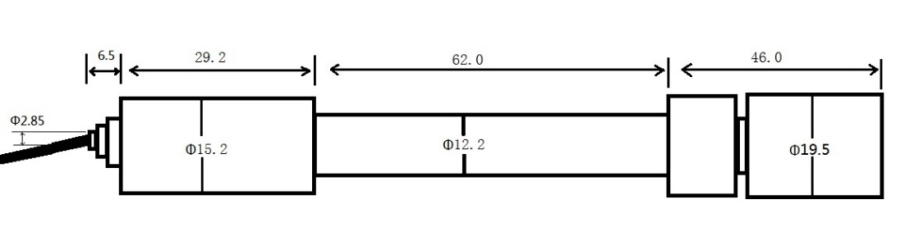

**Fig 4.6**

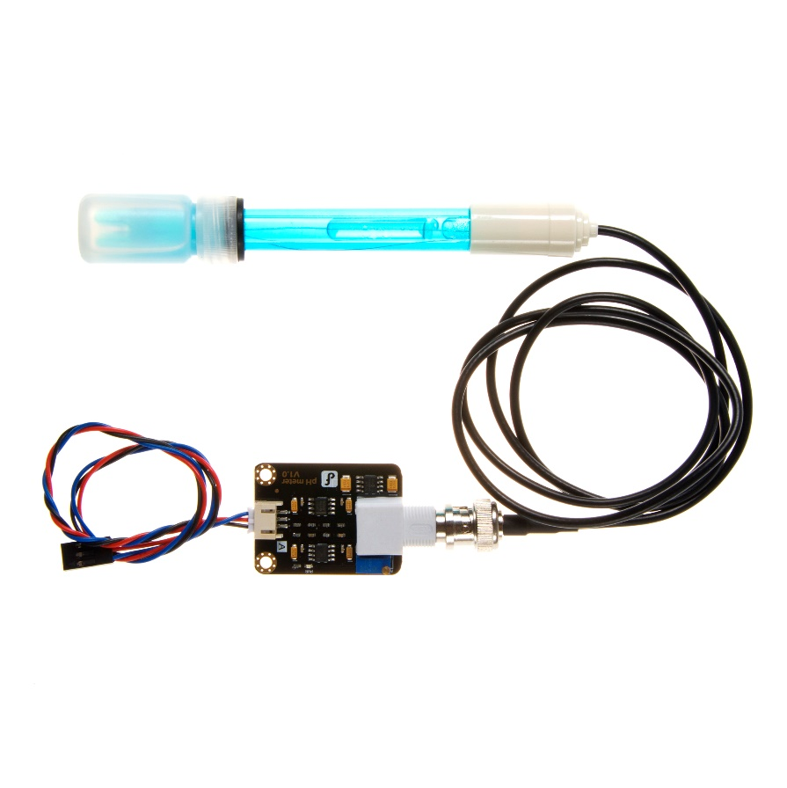

### Fig 4.7

### Step to Use the pH Meter

**Cautions:**

* Please use an external switching power supply,and the voltage as close as possible to the +5.00V. More accurate the voltage, more higher the accuracy!
* Before the electrode in continuous use every time,you need to calibrate it by the standard solution,in order to obtain more accurate results.The best environment temperature is about 25 ℃,and the pH value is known and reliable,close to the measured value. If you measure the acidic sample, the pH value of the standard solution should be 4.00.If you measure the alkaline sample, the pH value of the standard solution should be 9.18.Subsection calibration, just in order to get a better accuracy.
* Before the pH electrode measured different solutions, we need to use water to wash it. We recommend using deionized water.

**(1)**Connect equipments according to the graphic,that is,the pH electrode is connected to the BNC connector on the pH meter board，and then use the connection lines,the pH meter board is connected to the ananlong port 0 of the [Arduino controller](https://www.dfrobot.com/category-104.html). When the Arduino controller gets power,you will see the blue LED on board is on.

**(2)**Upload the sample code to the Arduino controller.

**(3)**Put the pH electrode into the standard solution whose pH value is 7.00，or directly shorted the input of the BNC connector.Open the serial monitor of the Arduino IDE,you can see the pH value printed on it,and the error does not exceed 0.3. Record the pH value printed,then compared with 7.00, and the difference should be changed into the "Offset" in the sample code. For example,the pH value printed is 6.88,so the difference is 0.12.You should change the "# define Offset 0.00" into "# define Offset 0.12" in your program.

**(4)**Put the pH electrode into the pH standard solution whose value is 4.00.Then wait about one minute,adjust the gain potential device, let the value stabilise at around 4.00.At this time,the acidic calibration has been completed and you can measure the pH value of an acidic solution. **Note:If you want to measure the pH value of other solution,you must wash the pH electrode first!**

**(5)** According to the linear characteristics of pH electrode itself, after the above calibration,you can directly measure the pH value of the alkaline solution, but if you want to get better accuracy, you can recalibrate it. Alkaline calibration use the standard solution whose pH value is 9.18.Also adjust the gain potential device, let the value stabilise at around 9.18. After this calibration, you can measure the pH value of the alkaline solution.

## **Specification**

* Module Power : 5.00V
* Module Size : 43mm×32mm
* Measuring Range:0-14PH
* Measuring Temperature :0-60 ℃
* Accuracy : ± 0.1pH (25 ℃)
* Response Time : ≤ 1min
* pH Sensor with BNC Connector
* PH2.0 Interface ( 3 foot patch )
* Gain Adjustment Potentiometer
* Power Indicator LED

### pH Electrode Characteristics

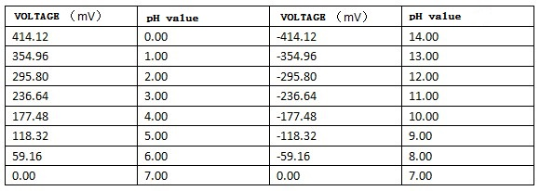

## **Applications**

* Water quality testing
* Aquaculture

# **MQ-2 Smoke Methane Gas liquefied Flammable Gas Sensor**

MQ2 is one of the commonly used gas sensors in MQ sensor series. It is a Metal Oxide Semiconductor (MOS) type Gas Sensor also known as Chemiresistors as the detection is based upon change of resistance of the sensing material when the Gas comes in contact with the material. Using a simple voltage divider network, concentrations of gas can be detected.

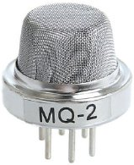

**Fig 4.8**

MQ2 Gas sensor works on 5V DC and draws around 800mW. It can detect LPG, Smoke, Alcohol, Propane, Hydrogen, Methane and Carbon Monoxide concentrations anywhere from 200 to 10000ppm.

**specifications**

|  |  |
| --- | --- |
| Operating voltage | 5V |
| Load resistance | 20 KΩ |
| Heater resistance | 33Ω ± 5% |
| Heating consumption | <800mw |
| Sensing Resistance | 10 KΩ – 60 KΩ |
| Concentration Scope | 200 – 10000ppm |
| Preheat Time | Over 24 hour |

## **Internal structure of MQ2 Gas Sensor**

The sensor is actually enclosed in two layers of fine stainless steel mesh called **Anti-explosion network**. It ensures that heater element inside the sensor will not cause an explosion, as we are sensing flammable gases.

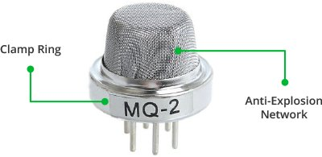

**Fig 4.9**

It also provides protection for the sensor and filters out suspended particles so that only gaseous elements are able to pass inside the chamber. The mesh is bound to rest of the body via a copper plated clamping ring.

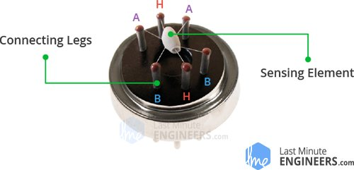

**Fig 4.10**

This is how the sensor looks like when outer mesh is removed. The star-shaped structure is formed by the sensing element and six connecting legs that extend beyond the Bakelite base. Out of six, two leads (**H**) are responsible for heating the sensing element and are connected through **Nickel-Chromium coil**, well known conductive alloy.

The remaining four leads (**A** & **B**) responsible for output signals are connected using **Platinum Wires**. These wires are connected to the body of the sensing element and convey small changes in the current that passes through the sensing element.

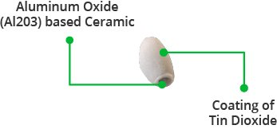

**Fig 4.11**

The tubular sensing element is made up of **Aluminum Oxide** (AL2O3) based ceramic and has a coating of **Tin Dioxide** (SnO2). The Tin Dioxide is the most important material being sensitive towards combustible gases. However, the ceramic substrate merely increases heating efficiency and ensures the sensor area is heated to a working temperature constantly.

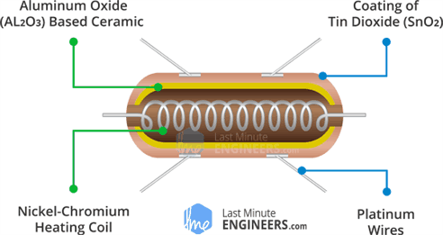

**Fig 4.12**

So, the Nickel-Chromium coil and Aluminum Oxide based ceramic forms a **Heating System**; while Platinum wires and coating of Tin Dioxide forms a **Sensing System.**

## **How does a gas sensor work?**

When tin dioxide (semiconductor particles) is heated in air at high temperature, oxygen is adsorbed on the surface. In clean air, donor electrons in tin dioxide are attracted toward oxygen which is adsorbed on the surface of the sensing material. This prevents electric current flow.

In the presence of reducing gases, the surface density of adsorbed oxygen decreases as it reacts with the reducing gases. Electrons are then released into the tin dioxide, allowing current to flow freely through the sensor.

Since MQ2 Gas Sensor is not breadboard compatible, we do recommend this handy little breakout board. It’s very easy to use and comes with two different outputs. It not only provides a binary indication of the presence of combustible gases but also an analog representation of their concentration in air.

The analog output voltage provided by the sensor changes in proportional to the concentration of smoke/gas. The greater the gas concentration, the higher is the output voltage; while lesser gas concentration results in low output voltage. The following animation illustrates the relationship between gas concentration and output voltage.

he analog signal from MQ2 Gas sensor is further fed to LM393 High Precision Comparator (soldered on the bottom of the module), of course to digitize the signal. Along with the comparator is a little potentiometer you can turn to adjust the sensitivity of the sensor. You can use it to adjust the concentration of gas at which the sensor detects it .

## **MQ2 Gas Sensor Module Pinout**

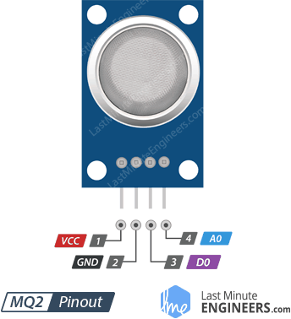

**Fig 4.13**

VCC supplies power for the module. You can connect it to 5V output from your Arduino.

GND is the Ground Pin and needs to be connected to GND pin on the Arduino.

D0 provides a digital representation of the presence of combustible gases.

A0 provides analog output voltage in proportional to the concentration of smoke/gas.

## **Wiring – Connecting MQ2 Gas Sensor Module to Arduino UNO**

Now that we have a complete understanding of how MQ2 Gas sensor works, we can begin hooking it up to our Arduino!

Connecting the MQ2 Gas sensor module to the Arduino is pretty easy. Start by placing the sensor on to your breadboard. Connect VCC pin to the 5V pin on the Arduino and connect GND pin to the Ground pin on the Arduino. Connect D0 output pin on the module to Digital pin#8 on the Arduino and A0 output pin on the module to Analog pin#0 on the Arduino.

# **433 MHz RF Transmitter Module**

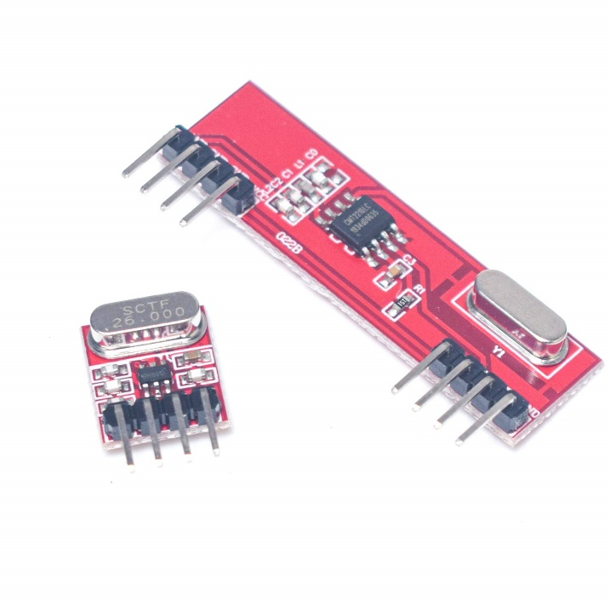

**Fig 4.14**

## **433MHz RF Transmitter & Receiver Pinout**

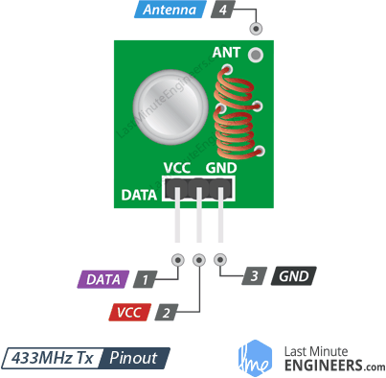

**Fig 4.15**

DATA pin accepts digital data to be transmitted.

VCC supplies power for the transmitter. This can be any positive DC voltage between 3.5V to 12V. Note that the RF output is proportional to the supply voltage i.e. the higher the Voltage, the greater the range will be.

GND is a ground pin.

Antenna is a pin for external antenna. As discussed earlier, you will want to solder a 17.3 cm piece of solid wire to this pin for the improved range

**433 MHz Module Specifications:**

* Wireless (RF) Simplex Transmitter and Receiver
* Transmitter Operating Voltage: +5V only
* Transmitter Operating current: 9mA to 40mA
* Operating frequency: 433 MHz
* Transmission Distance: 3 meters (without antenna) to 100 meters (maximum)
* Modulating Technique: ASK (Amplitude shift keying)
* Data Transmission speed: 10Kbps
* Circuit type: Saw resonator
* Low cost and small package
* The 433MHz wireless module is one of the cheap and easy to use modules for all wireless projects. These modules can be used only in pairs and only simplex communication is possible. Meaning the transmitter can only transmit information and the receiver can only receive it, so you can only send data from point A to B and not from B to A.
* The module could cover a minimum of 3 meters and with proper antenna a power supplies it can reach upto 100 meters theoretically. But practically we can hardly get about 30-35 meters in a normal test conditions.
* So if you are looking for a simple wireless communication to transmit information within a short distance then these RF pair could be the right choice.

### How to use 433MHz RF modules:

The module itself cannot work on its own as it required some kind of encoding before being transmitter and decoding after being received; so it has to be used with an encoder or decoder IC or with any microcontroller on both ends. The simplest way to use it is with the [HT12E Encoder](https://components101.com/ht12e-encoder-pin-diagram-datasheet)and [HT12D Decoder IC](https://components101.com/ht12d-rf-decoder-ic).

The module uses ASK (Amplitude shift keying) and hence it’s easy to interface with microcontrollers as well. If you are trying to use this with Arduino, then the Radiohead library would make things easy for you. However you cannot expect noiseless data for a long distance form this module as this is very much susceptible to noise. The rage depends on the voltage supplied to Receiver and the noise present in the environment.

**Applications:**

* Home automation
* Transmit Serial data for short distance
* Car security system
* Wireless logging
* Short distance communication

.

**LCD Display**

Stands for "Liquid Crystal Display." LCD is a flat panel display technology commonly used in TVs and computer monitors. It is also used in screens for mobile devices, such as laptops, tablets, and smartphones .

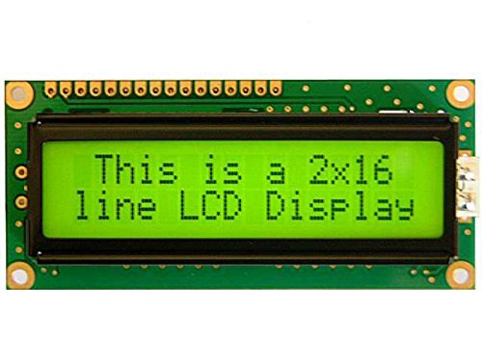

5V DC 16 x 2 Lines ASCII Character LCD Display With Yellow Backlight Product Description: o LCD display module with Yellow Backlight o SIZE : 20x4 (2 Rows and 16 Characters Per Row) o Can display 2-lines X 16-characters o Operate with 5V DC o Wide viewing angle and high contrast o Built-in industry standard HD44780 equivalent LCD controller o Commonly Used in: Student Project, Collage,copiers, fax machines, laser printers, industrial test equipment, networking equipment such as routers and storage devices o LCM type: Characters ABOUT This is a basic 16 character by 2 line display Yellow Back light . Utilizes the extremely common HD44780 parallel interface chipset (datasheet). Interface code is freely available. You will need 7 general I/O pins(If use in 4-bit Mode) to interface to this LCD screen. Includes LED backlight. Package Contains: 1 X 16X2 LCD.

**Features of 16×2 LCD module**

* Operating Voltage is 4.7V to 5.3V
* Current consumption is 1mA without backlight
* Alphanumeric LCD display module, meaning can display alphabets and numbers
* Consists of two rows and each row can print 16 characters.
* Each character is build by a 5×8 pixel box
* Can work on both 8-bit and 4-bit mode
* It can also display any custom generated characters
* Available in Green and Blue Backlight

**Chapter No 5 -: Software required for the project**

**Software for simulation-:PROTEUS 8.7**

The **Proteus Design Suite** is a proprietary software tool suite used primarily for [electronic design automation](https://en.wikipedia.org/wiki/Electronic_design_automation). The software is used mainly by electronic [design engineers](https://en.wikipedia.org/wiki/Design_engineer) and technicians to create [schematics](https://en.wikipedia.org/wiki/Schematic) and electronic prints for manufacturing [printed circuit boards](https://en.wikipedia.org/wiki/Printed_circuit_board).

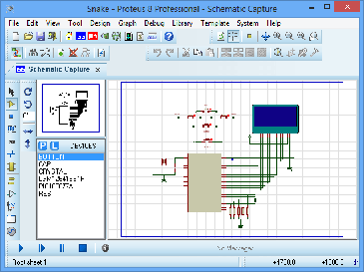

**Fig 5.1**

## **Product Modules**

The Proteus Design Suite is a Windows application for [schematic capture](https://en.wikipedia.org/wiki/Schematic_capture), [simulation](https://en.wikipedia.org/wiki/Computer_simulation), and PCB ([Printed Circuit Board](https://en.wikipedia.org/wiki/Printed_Circuit_Board)) layout design. It can be purchased in many configurations, depending on the size of designs being produced and the requirements for microcontroller simulation. All PCB Design products include an autorouter and basic mixed mode SPICE simulation capabilities.

### Schematic Capture

Schematic capture in the Proteus Design Suite is used for both the simulation of designs and as the design phase of a PCB layout project. It is therefore a core component and is included with all product configurations.

### Microcontroller Simulation

The micro-controller simulation in Proteus works by applying either a hex file or a debug file to the microcontroller part on the schematic. It is then co-simulated along with any analog and digital electronics connected to it. This enables its use in a broad spectrum of project prototyping in areas such as motor control,[[2]](https://en.wikipedia.org/wiki/Proteus_Design_Suite#cite_note-bldc-2)[[3]](https://en.wikipedia.org/wiki/Proteus_Design_Suite#cite_note-induction-3) temperature control and user interface design. It also finds use in the general hobbyist community[[7]](https://en.wikipedia.org/wiki/Proteus_Design_Suite#cite_note-arduinosim-7)[[8]](https://en.wikipedia.org/wiki/Proteus_Design_Suite#cite_note-elecnote-8) and, since no hardware is required, is convenient to use as a trainingor teaching tool.[[11]](https://en.wikipedia.org/wiki/Proteus_Design_Suite#cite_note-edu2-11)[[12]](https://en.wikipedia.org/wiki/Proteus_Design_Suite#cite_note-edu1-12) Support is available for co-simulation of:

* [Microchip Technologies](https://en.wikipedia.org/wiki/Microchip_Technology) PIC10, PIC12, PIC16,PIC18,PIC24,dsPIC33 Microcontrollers.
* [Atmel](https://en.wikipedia.org/wiki/Atmel) AVR (and [Arduino](https://en.wikipedia.org/wiki/Arduino)), 8051 and [ARM Cortex-M3](https://en.wikipedia.org/wiki/ARM_Cortex-M#Cortex-M3) Microcontrollers
* [NXP](https://en.wikipedia.org/wiki/NXP_Semiconductors) 8051, ARM7, [ARM Cortex-M0](https://en.wikipedia.org/wiki/ARM_Cortex-M#Cortex-M0) and ARM Cortex-M3 Microcontrollers.
* [Texas Instruments](https://en.wikipedia.org/wiki/Texas_Instruments) MSP430, PICCOLO DSP and ARM Cortex-M3 Microcontrollers.
* Parallax Basic Stamp, Freescale HC11, 8086 Microcontrollers.

### PCB Design

The PCB Layout module is automatically given connectivity information in the form of a [netlist](https://en.wikipedia.org/wiki/Netlist) from the schematic capture module. It applies this information, together with the user specified [design rules](https://en.wikipedia.org/wiki/Design_rule_checking) and various design automation tools, to assist with error free board design. PCB's of up to 16 copper layers can be produced with design size limited by product configuration.

### 3D Verification

The 3D Viewer module allows the board under development to be viewed in 3D together with a semi-transparent height plane that represents the boards enclosure. [STEP](https://en.wikipedia.org/wiki/ISO_10303-21) output can then be used to transfer to mechanical CAD software such as [Solidworks](https://en.wikipedia.org/wiki/Solidworks) or [Autodesk](https://en.wikipedia.org/wiki/Autodesk) for accurate mounting and positioning of the board.

**Software for uploading programm in Arduino**

**Arduino IDE 1.8.13**

The Arduino Integrated Development Environment ([IDE](https://en.wikipedia.org/wiki/Integrated_development_environment)) is a [cross-platform](https://en.wikipedia.org/wiki/Cross-platform) application (for [Windows](https://en.wikipedia.org/wiki/Windows), [macOS](https://en.wikipedia.org/wiki/MacOS), [Linux](https://en.wikipedia.org/wiki/Linux)) that is written in functions from [C](https://en.wikipedia.org/wiki/C_(programming_language)) and [C++](https://en.wikipedia.org/wiki/C%2B%2B_(programming_language)). It is used to write and upload programs to [Arduino](https://en.wikipedia.org/wiki/Arduino) compatible boards, but also, with the help of third-party cores, other vendor development boards.

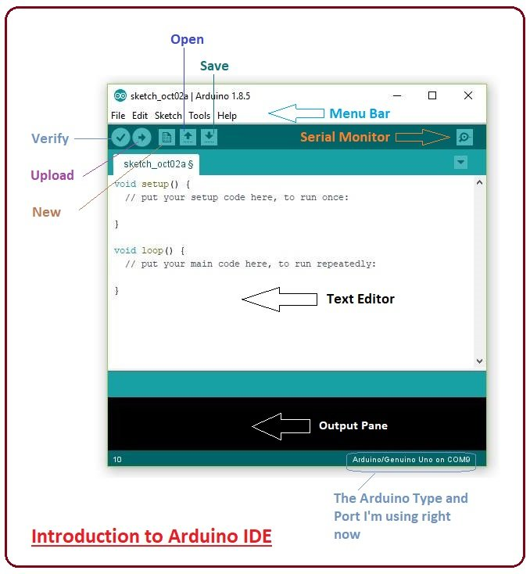

**Fig 5.2**

The open-source Arduino Software (IDE) makes it easy to write code and upload it to the board. This software can be used with any Arduino board. he source code for the IDE is released under the [GNU General Public License](https://en.wikipedia.org/wiki/GNU_General_Public_License), version 2. The Arduino IDE supports the languages [C](https://en.wikipedia.org/wiki/C_(programming_language)) and [C++](https://en.wikipedia.org/wiki/C%2B%2B) using special rules of code structuring. The Arduino IDE supplies a [software library](https://en.wikipedia.org/wiki/Software_library) from the [Wiring](https://en.wikipedia.org/wiki/Wiring_(development_platform)) project, which provides many common input and output procedures. User-written code only requires two basic functions, for starting the sketch and the main program loop, that are compiled and linked with a program stub main() into an executable [cyclic executive](https://en.wikipedia.org/wiki/Cyclic_executive) program with the [GNU toolchain](https://en.wikipedia.org/wiki/GNU_toolchain), also included with the IDE distribution. The Arduino IDE employs the program avrdude to convert the executable code into a text file in hexadecimal encoding that is loaded into the Arduino board by a loader program in the board's firmware. By default, avrdude is used as the uploading tool to flash the user code onto official Arduino boards.

|  |  |
| --- | --- |
| Arduino Pro IDE | |
| [Developer(s)](https://en.wikipedia.org/wiki/Software_developer) | Arduino Software |
| [Preview release](https://en.wikipedia.org/wiki/Software_release_life_cycle#BETA) | v0.1.2 / 14 September 2020; 4 months ago[[9]](https://en.wikipedia.org/wiki/Arduino_IDE#cite_note-9) |
| [Repository](https://en.wikipedia.org/wiki/Repository_(version_control)) | * [github.com/arduino/Arduino](https://github.com/arduino/Arduino)   [Edit this at Wikidata](https://www.wikidata.org/wiki/Q55080330#P1324) |
| Written in | [C](https://en.wikipedia.org/wiki/C_(programming_language)), [C++](https://en.wikipedia.org/wiki/C%2B%2B) |
| [Operating system](https://en.wikipedia.org/wiki/Operating_system) | [Windows](https://en.wikipedia.org/wiki/Windows), [macOS](https://en.wikipedia.org/wiki/MacOS), [Linux](https://en.wikipedia.org/wiki/Linux) |
| [Platform](https://en.wikipedia.org/wiki/Computing_platform) | [IA-32](https://en.wikipedia.org/wiki/IA-32), [x86-64](https://en.wikipedia.org/wiki/X86-64), [ARM](https://en.wikipedia.org/wiki/ARM_architecture) |
| [Type](https://en.wikipedia.org/wiki/Software_categories#Categorization_approaches) | [Integrated development environment](https://en.wikipedia.org/wiki/Integrated_development_environment) |
| [License](https://en.wikipedia.org/wiki/Software_license) | [LGPL](https://en.wikipedia.org/wiki/GNU_Lesser_General_Public_License) or [GPL](https://en.wikipedia.org/wiki/GNU_General_Public_License) license |

**Algorithem**

**At the transmitter end**

Step1: start

Step2: define the analog input pins for each sensor and digital pins to , rf transmitter module , buzzer

Step3: read the input values from the sensors through analog pins assign to each sensor

Step4: compare the sensor value with a set standard value

Step5: if input value is beyond the set standard values of each sensor or any one sensor then set high to the pin connected to buzzer .

Step6: send data on pin conneted to transmitter module

Step7: end

**At the receiver end**

Step1: start

Step2:define the digital pins to LCD display and RF receiver module

Step3: read the data on pin connected to receiver module

Step4: write that data on LCD display

Step5:end

**At the transmitter end**

**Flow chart**

End

Transmit data to RF module

Ring the Buzzer

if read data > standard data

Read the analog pins(sensors )

define the analog input pins for each sensor and digital pins to , rf transmitter module , buzzer

Start

true

false

**At the receiver end**

End

Write the data on pins connected to LCD display

Read the data from pin conneted to RF module

start

define the digital pins to LCD display and RF receiver module